
School of Business & Management

[Module Name] Assessment Brief

Assessment Overview
- Title: [Insert title]
- Type: [e.g., Essay, Report, Presentation, Group Project – provide a definition of each]
- Weighting: [X% of total Module grade]
- Word Count/Duration: [Insert word count or duration]
- Submission Deadline: [Date and Time]

Learning Outcomes and Skills
The Module gave you the opportunity to explore the following ideas and concepts in depth:
1. [insert here]

Through this assessment you will demonstrate your learning on the Module.
Specifically, the course learning outcomes being assessed are:

1. [insert here only those learning outcomes assessed in this specific assessment. Please use the course level learning outcomes as per the new course design.]

At the same time, through this assessment you will demonstrate particular skills which you have acquired through the learning on the Module. These are:

1. [insert here]

Assessment Task – In Detail
[Provide a clear and concise description of the assessment task, including its purpose and relevance to the Module content and real-world applications.]

The Module has taught you: [enter your own text here]

Therefore, to demonstrate your learning on this Module, for this assessment you are required to: [enter your own text here]

This is an authentic assessment. In the real world, what you learn through this assessment is relevant because: [enter your own text here]

To complete this assessment and to perform well, you are expected to draw on and provide evidence of application of ALL of the learning on the Module, as well as your own independent study in which you have engaged during the course of the Module.

Resources
You can find core resources you will need to use listed below.

Taught Material:

Knowledge: Lecture slides weeks [enter here which weeks provided content for assessment], plus material covered and examples used by your Lecturer during class
Application: Material and application which you learned in workshops in weeks [enter here]

Where to find:
[enter Moodle info here]

Essential Readings/Watching:

- Academic journal articles
- Videos [links here]

Where to find:
[enter library, online details here]

Other Sources:

- [enter here]

Where to find:
[enter details here]

Independent Study:

During the course of the Module, you were required to [enter your own text here]. You will need to draw on this learning also and apply it to your assessment.

Use of AI
For this particular assessment, you are:
[delete as appropriate]

- Required to use AI – the suggested tools are:[insert text here]
- Encouraged to use AI – the suggested tools are:[insert text here]
- Prohibited from using AI – it is an academic offence to use AI for this assessment

For the University regulations and procedures on AI use, visit here. Remember, that if you are not permitted to use AI and you use it, this will be treated in the same way as all other academic misconduct offences. For information and guidance on academic misconduct, visit here. If you are unclear, do talk to your Module Leader.
If you are permitted or encouraged to use AI, there are some suggested tools in Appendix 1 which can help to improve your work. This is by no means a comprehensive list.

Assessment Marking Criteria
Your work will be assessed based on [enter the key elements of your rubric here], you can find the full marking criteria on Moodle:
[example, enter your own detail in table]

Criterion | Weighting | Description
Knowledge Base | 20% | Accurate comprehension of key concepts
Application of Theory | 25% | Appropriate use of models and theories
Critical Analysis | 30% | Depth of analysis and justified evaluations
Creativity and Innovation | 15% | Original ideas and innovative solutions
Academic Writing | 10% | Clarity, structure, and correct referencing

Inclusive Learning Support
We are committed to supporting all learners. Contact your Module Leader [Name, Email] to discuss any specific accommodations you may need throughout you study on the Module. If there are any topics you wish to discuss that go beyond your module but impact your learning, please get in touch with our Vice Dean for Equality, Diversity, and Inclusion, Anica Zeyen, anica.zeyen@rhul.ac.uk. For all types of support, see Appendix 2.

Assessment Planning: SUPER PLAN
Make sure you start planning your assessment well in advance of the due date. You may wish to adopt the School of Business & Management SUPER PLAN framework. (Description included in ALT text)

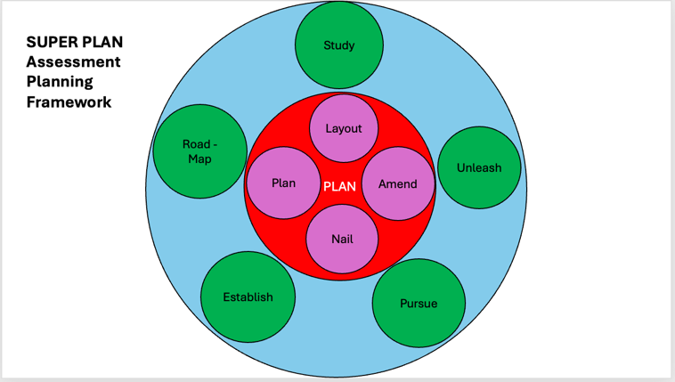

S - Study the assessment brief carefully making sure you understand the assessment requirements. Read the marking rubric carefully.
U - Unleash ideas: Generate and explore potential topics or approaches to the assessment. Make a note of your ideas.
P - Pursue research: gather and evaluate relevant sources and information.
E - Establish thesis: create a clear main argument or thesis statement that addresses the assessment brief. Draw this out.
R - Roadmap the structure: outline the structure of the assessment, section by section.
P - Plan time management: break the assessment into smaller tasks and set yourself mini-deadlines.
L - Layout the draft: write/record/create a rough draft of the assessment.
A - Amend and improve: review your work, checking against the rubric, then improve, and polish your work.
N - Nail the final details: conduct a final review to ensure all requirements are met and the assessment is ready for submission.

Feedback on your Assessment
You will receive a grade and written feedback for all coursework, the feedback will highlight areas of work which have been well executed and areas requiring improvement. You will then need to reflect on this information and act on it in future assessments to help you build on previous work. This way, you should be able to progressively improve as you work through your degree.

Academic Regulations
Ensure your work adheres to the University’s academic regulations policy. You can find details here.

Submission
Once you have completed your assessment and are ready to submit, check the following before making your submission to Turnitin:

Submission Checklist

- Met word count/duration requirement
- Included correct citations and reference list
- Addressed all parts of the assessment brief
- Demonstrated skills being assessed
- Proofread for grammar and spelling errors
- Formatted according to required style guide
- Acknowledged the use of AI (where AI usage is explicitly required)
- Checked submission is in format/file required (e.g. PDF, Panopto, PowerPoint)
- Checked use of correct submission box on Moodle
- Opened and checked you have uploaded the correct file once uploaded
Once you have checked all of the above, you are ready to submit. Make sure you submit well in advance of the deadline to avoid risk of late penalties.

Questions/Support
Contact:
- Module Leader: [Name, Email]
- Workshop Tutor: [Name, Email]

Good luck with your assessment!
Appendix 1: AI tools for students and researchers

For Design and images
Image generator: Icons8
Gradient generator: My Color Hub
Colour Palette generator: Colors
Remove image background: Remove bg
Infographic Generator: Piktochart
Design and infographic production: Canva
For Audio and Video
Sound generator: Eleven Labs Sound Generator
Audio clean up: Eleven Labs Voice Isolator
Transcription: Speech-to-Text (first 60 minutes free per month)
Writing
For translation – Cloud Translation API (first 500,000 characters free per month)
Writing assistance – Grammarly
Read aloud (great for proofreading) - Speechify
Copywriting - unbounce

Summary and Analysis
To complete simple research tasks and summarising texts: Chat GBT
For visual analysis: Cloud Vision (first 1,000 units free per month)
Explain concepts: Chat PDF
Summarise YouTube videos: Summarize Tech
Summarise long texts: Claude
Admin and other
Scheduling: ReclaimAI
Meeting notes and summaries: Otter-ai
Task management: Taskade
For preparing presentations: Plus AI
For coding support: Gemini Code Assist (free until 8 December 2024)

Neurodivergence-Friendly options
Meeting notes and summaries: Fireflires.ai
Write within guidelines provided: Writer
Ask for help on next step: Chameleon
Mindmapping: Gitmind

Appendix 2: Support Services and Resources for your Assessment
There are many support services and resources available to you while you work on your assessment.

Library Support
The library offers lots of support in provision of books, journals, online services and also learning spaces which are designed to help you to succeed. You can visit the library in person and find one of the many study spaces in which to study in peace or with friends and take the opportunity to browse the collection. Alternatively, you can also find all that you need online. Just remember that if you are not on campus, you need to connect to the VPN to enjoy full access to the library resources. You can also get help with finding the resources you need and how to reference correctly. You can even book a one-to-one appointment with the School’s library specialist. All details can be found here.

CeDAS Support
CeDAS provides a range of services to support you. They offer group sessions, 1:1 tutorials, drop-ins and resources tailored to studying in your subject area. These activities are delivered both online and in-person and address key aspects of academic writing and communication and studying independently. All details can be found here.

IT Support
If you encounter technical difficulties, do not contact your Module Leader as they are unable to help. Support from the IT department can be found here.

Wellbeing Support
If you are feeling overwhelmed, stressed, worried, or anxious, you can contact the University’s wellbeing services. All details can be found here. You can get in touch with wellbeing about you feel your assessment impacts your wellbeing or if something else in your life impacts your ability to work on your assessment. You can also talk to your personal tutor. Please use this service if you are finding things challenging or are struggling. They are here to help you.

Module Forum
Your module leader has created a forum on Moodle where you can pose questions, make sure you use this forum to support you during preparation of your assessment. Your peers may have posed questions you haven’t thought of.

Peer Support
Create a working together group with peers on your Module. Meet online or on campus to study together and to support one another. Just make sure that if you have questions about specific aspects of the assessment like length, what should be included and what should be left out, the case you need to work on or similar, to check this assessment brief or ask your workshop tutor or lecturers.
Support from Feedback
Look back over the feedback you have received along the way in classes, in feedback hours or in the Q & A section on Moodle. Look particularly at similar types of earlier assessments and see what you did well and make sure you repeat it. Look at areas suggesting improvement, and make sure those are addressed in the new task. Acting on previous feedback to inform your assessment is very good practice and this helps you to build up your learning and enhance performance.

SS1001: Academic Integrity
Revisit Module SS1001 to remind yourself all that you learned on academic integrity, making sure you have applied the principles.

Module Leader/Workshop Tutor
If you have questions or wish to discuss your work on the assessment in more detail, make sure to visit your Module Leader and/or Workshop Tutor during their weekly feedback hours. These will be sign posted on Moodle.

