Training the Audience
David Overend

As a Glasgow-based theatre director – typically of new Scottish writing – I collaborate on a regular basis with the playwright-performer, Rob Drummond. This partnership began at the recently-closed Arches arts centre in Glasgow in the early 2000s, and over the last 15 years we have worked with several producing theatres in the UK on almost 20 productions, occasionally touring our work internationally (Overend 2015). In our latest work, the active involvement of the audience has become increasingly important. Rob, along with other cast-members, frequently addresses the audience directly, offering them an invitation: to cast their votes; to respond to arguments and propositions; to shout out, make themselves known, alter the course of the performance. While a fixed narrative almost always exists, we have begun to open our texts to improvised sections, discussion and debate, which we fold back into the carefully structured advancement of a story. This new dramaturgy has necessitated a shift in our rehearsal techniques. It is now no longer possible to see public performances as a final stage of the process. Rather, audiences have to be invited into the rehearsal room from the start, allowing us to try out ideas, discover new relationships, and adapt to the reactions that we encounter. We are honing our craft by subjecting ourselves to unexpected interventions, and preparing for a range of potential responses. In this short essai, I want to consider this as a reciprocal process, and ask whether, and in what ways, we are also training the audience.

Our rehearsal audiences are usually comprised of theatre staff, associated artists and undergraduate students. They are generally recruited on an ad hoc basis by the project’s producer, but in the case of The Majority (National Theatre 2017) we utilised social media in a more directed way, promoting the opportunity to rehearse with us more widely, and drawing in members of the public with no association to the creative team or the producing theatre. The number of audience members depends on the nature of the work we are doing: Bullet Catch (The Arches 2012) often needed just one volunteer at a time to rehearse on-stage participation; and The Majority required at least 15 people, to incorporate group voting into the rehearsal process. In all cases, we are interested in replicating the conditions of the performances – unpredictable responses from an unprepared audience – and as a result we only invite participants once. Much of our drama arises from genuinely not knowing what is going to happen next.

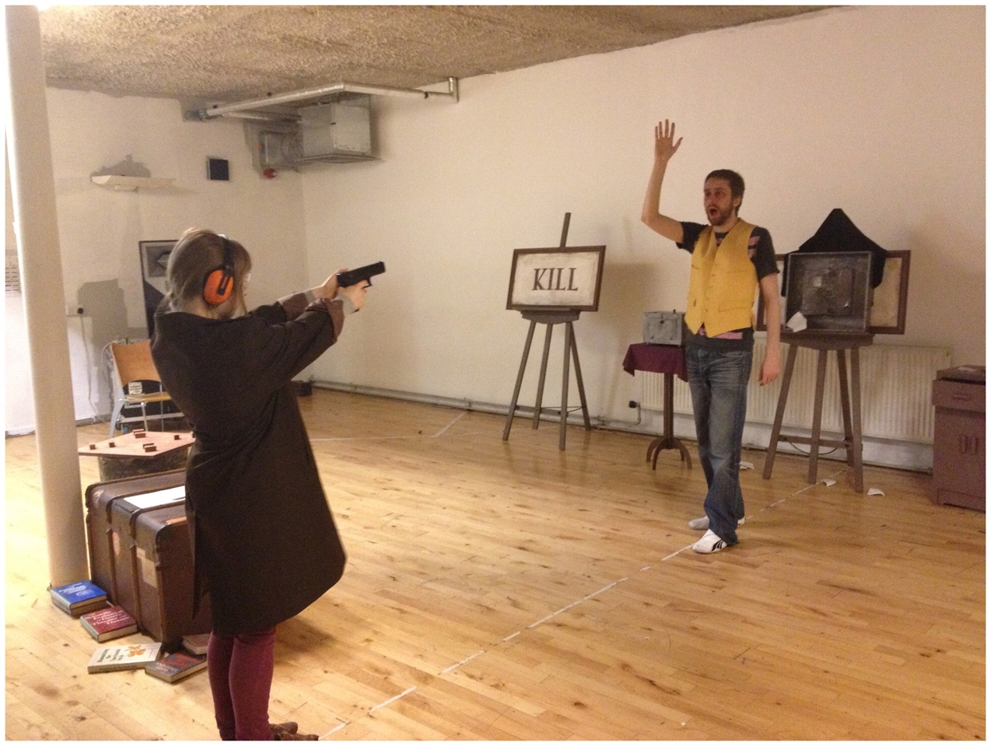
Rob Drummond and a volunteer rehearse Bullet Catch at the Arches, Glasgow, 2012

Improvisation is key to these sessions. The challenge is to very quickly create the conditions for an informal and creative exchange between the performers and the audience. The ‘briefing’ which we present at the start of the rehearsal includes the context for the production and sets out the aims for that afternoon (it is usually an afternoon session, which gives us time to reflect on the outcome before we return to a ‘closed’ room the following day). Participants are then invited to ‘work with us, rather than against us’ by embracing an exploratory approach to our material, testing and interrogating content as it develops. This relationship is established through a simple task or game, which offers an opportunity to test specific components of the productions – trying out a new magic trick, for example, or exploring different ways of structuring votes. We then perform short excerpts of prepared material and use these to prompt an improvised exchange.

The movement between open dialogue and scripted performance that we utilise in rehearsal can often be seen in our public performances. In Bullet Catch, for example, Rob performs a magic trick (he makes a table float) before, controversially, asking the audience to decide whether they want him to reveal how it is done. The moral and ethical debate that this prompted was initiated, and honed, with and by our rehearsal audiences. This became an important part of this performance, as it emerged from, and enhanced, its concern with truth, belief and faith (Megson 2016). A key part of the rehearsal process is exploring a variety of ways to incorporate these ‘open’ sections into the more tightly scripted dialogue around them. We are working together with the audience, learning collectively when to challenge each other, when to ask deeper questions, and when to move on.

After each new rehearsal task, we ask the audience to reflect on their role, and ascertain whether they understand what was asked of them, whether they felt able to contribute, and how much agency they experienced. This allows us to make changes to the set up, and to adjust the frame for audience-performer exchanges. This is a constant process of re-writing in the moment of performance, which pre-empts more permanent changes to the script. At the end of the day, the final ‘debriefing’ takes a wider perspective, exploring and interrogating the emerging performance text together. During these sessions, a creative exchange takes place, which may lead to a shared sense of progress and development that can be usefully understood as a form of training.

An invited audience in rehearsal for Wallace at The Arches, Glasgow, 2014

Over the course of the rehearsal period, multiple audiences join us to engage with a new project at various stages of development. They encounter the work only once, for half a day at the most. How is it possible, then, to talk about training them? We might assume that training requires time to evolve new ideas and skills; that it is predicated on reiteration and repetition of technique; and that it relies on the depth of thinking and practicing that can only be accessed diachronically. But training can be quick, direct and light in its methods. For Murray and Pitches, ‘“training” to make and practice art is never singularly about the acquisition of skill or technique […] it is always – cannot help but be – an imaginative, fluid and open-ended series of negotiations around processes and outcomes whose parameters are never fully known, always, in part at least, to be re-invented and discovered afresh’ (2011, p.135). In the brief time that we have with each new audience, we learn to improvise together, interrogating actual and potential reactions to the stimuli of the script and the performers’ prompts.

By working with different groups in each new session, we are constantly renewing and reconfiguring the collaborative structure of the rehearsal room. This can be understood as a decoupling of training from longer term temporality: as a training practice, this approach favours spontaneity and immediacy, rather than relying on duration and gradual progression. However, in other ways, continuity remains vital to our work with audiences in rehearsal.

It is important to point out (to admit, even) that despite our countless unique and formative interactions with individual audience members and specific audiences, we do not only conceive of our audiences as an assemblage of unique and singular individuals. There is a sense in which our rehearsal work – in structuring scenes, honing prompts and propositions, designing transitions, tightening dramaturgy – leads to a gradual improvement in the role and function of the continual audience. I use this phrase to emphasise the past and future of an audience as it encounters multiple reiterations of a performance text. The audience is a coalescence of wilful, receptive and creative people, but it is also constituted through successive communities. This creates a sense of lineage and a progeny that is experienced in the present of performance. The continual audience gets better at what it is there to do. It collaborates more readily, responds more confidently, and learns when to retreat, to sit back, to shift its mode of engagement. Over time, it feels like this audience learns the rules and conventions that allow the drama to fulfil its potential. Ultimately, through training, the audience improves.

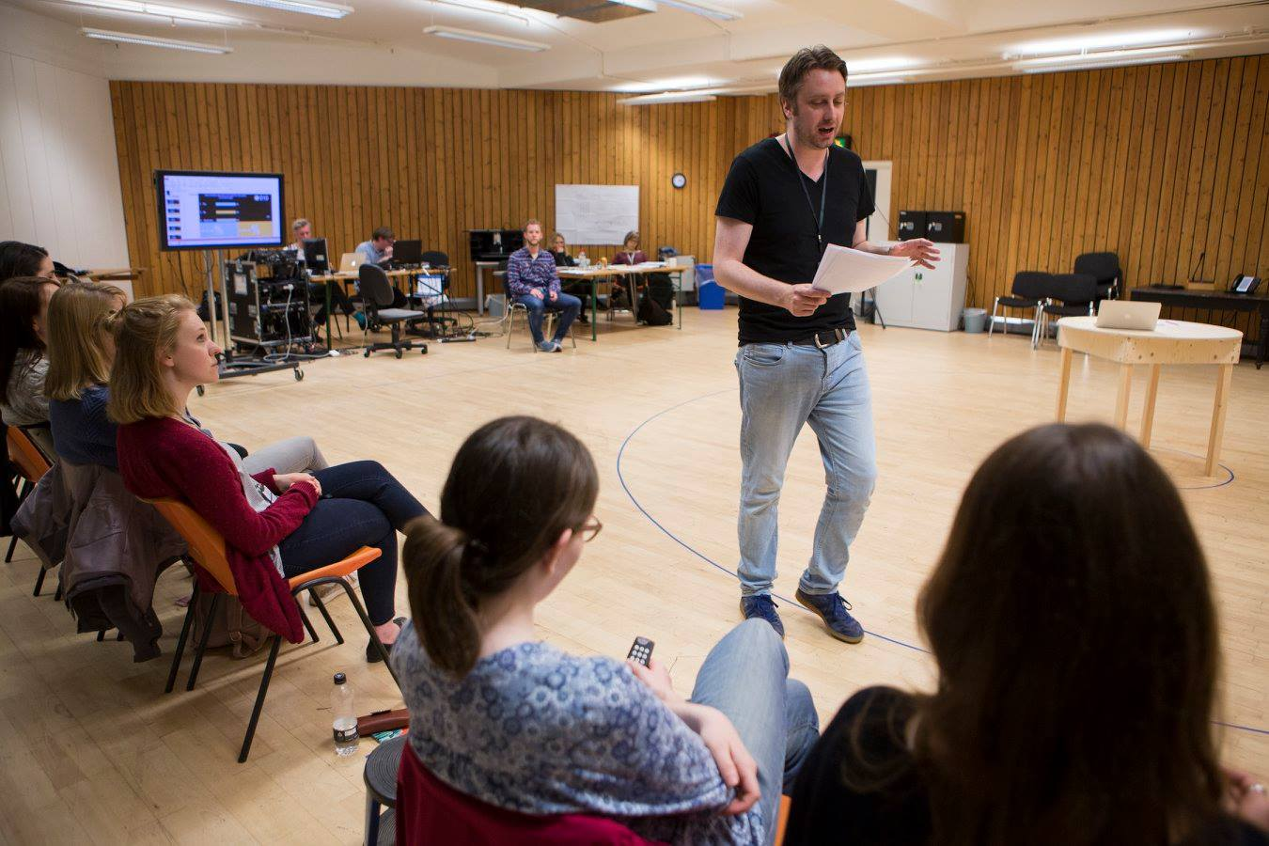 An invited audience in rehearsal for The Majority at National Theatre, London 2017. (c) Ellie Kurttz.

Of course, one could argue that it is, in fact, us who improve: it might feel like the change is taking place in the audience (who, remember, are always individuals coming together to encounter our work for the first time), but it is actually the performance text that is shifting and evolving, and the skill of the performers that is developing. This would suggest that our rehearsal audiences are only there to witness this process. But that does not seem to adequately capture the process of collaboration, and the sense of reciprocity, that takes place in our rehearsal room. Nor does it satisfactorily account for the strong impression of change and development in our audiences over the course of the rehearsal period (and often extending into the run).

To talk about training and rehearsing the audience continually reintroduces notions of duration, reiteration and depth to a discussion of audience training. It points to an evolution of practice over time and allows for one collective to pass on knowledge and skill to the next. That does not ignore or dismiss the unique and singular qualities of individual audience members. Quite the contrary. But it recognises the capacity for the continual audience to learn, develop and progress. The entire rationale for involving the audience so directly in our performances is that given the right context, they can offer a degree of passion, insight and creativity that can lift theatre to another level of meaning and humanity. Inviting them into the rehearsal room has allowed us to work collaboratively and to constantly develop our understanding of our audience, and this process will evolve as we continue to train together.

Bibliography

Drummond, R. (2012) Bullet Catch. Directed by Rob Drummond and David Overend. The Arches.

Drummond, R. (2014) Wallace. Directed by Rob Drummond and David Overend. National Theatre of Great Britain and the Arches.

Drummond, R. (2017) The Majority. Directed by David Overend. National Theatre of Great Britain.

Megson, C. (2016). Beyond Belief: British Theatre and the 're-enchantment of the world'. Twenty-First Century Drama: What happens now. Adiseshiah, S. & LePage, L. (eds.). London: Palgrave Macmillan, pp. 37-57.

Murray, J. and Pitches, S. (2011). Editorial Issue 2.2. Theatre, Dance and Performance Training 2:2, pp. 135-137.

Overend, D. (2015). Dramaturgies of Mobility: On the road with Rob Drummond’s Bullet Catch. Studies in Theatre and Performance 35:1, pp. 36-51.

In Bullet Catch (Drummond 2012) and The Majority (Drummond 2017), Rob appears on stage on his own, but in the former he invites a volunteer assistant to join him from the audience; and in the latter, the audience use voting handsets to directly affect the drama. In the first act of Wallace (Drummond 2014), a cast of seven, including Rob, respond to audience questions about Scottish Independence.

